Oliver Ames Swim and Dive Order Form
Sweatshirt
UA-$55 Gildan-$30
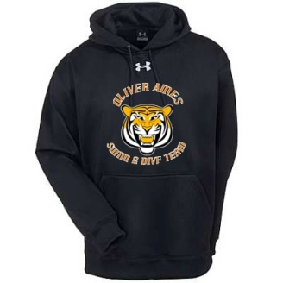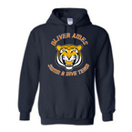
S M L XL XXL
Sweatpants
UA- $55 Jerzee-$25
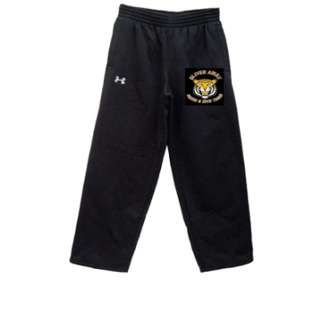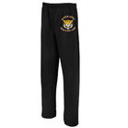
S M L XL XXL

Badger Adult Reversible Pinnie - $25
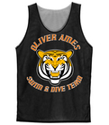
S M L XL XXL

